問．次の文章の下線部の引かれた and と or が何を並べているか示しなさい．
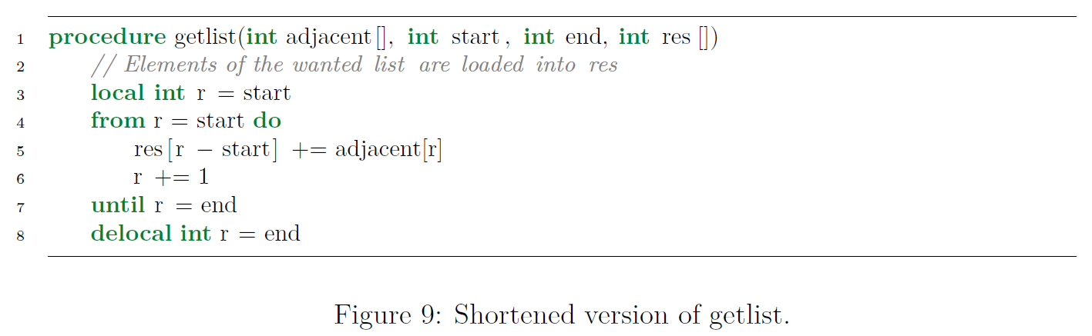
The second way is to represent an adjacency list in two arrays, one array a containing
all the edges, and another array r of size n containing the starting point of
each list, such that the first adjacent node of a node i is stored in the array from
a[r[i]], a[r[i + 1]], a[r[i + 2]], ..., a[r[i + |r| − 1]].
…
When creating the reversible algorithms, we will often have to find the current
list of adjacent nodes. In 9 we see a procedure that copies a subsection of a list
to a new array. We can use this to extract the adjacent nodes of a single node by providing the index value of the node as start, the index value of the next node or, in case of getting the list of the final node, the size of the edge list as end, as well as the adjacency list and the output array to store the adjacent nodes.
解答．
We can use this
S V O 以下は副詞句
to extract the adjacent nodes of a single node
V’ O’ 以下は副詞句
by providing
S’’ 以下はO’’
the index value of the node as start, start
the index value of the next node or, …,
the size of the edge list as end, end
as well as the adjacency list adjacent[]
and
the output array to store the adjacent nodes. res[]

and は the adjacency list と the output array … を並べている
or は the next node と the size of … を並べている

